A Project Report
On Restaurant Recommender Chatbot
AML 3406 AI and ML Capstone Project

Submitted by,
Swathi Gurijala (C0790294)
Varadharajan Kalyanaraman (C0793756)
Vignesh Kumar Murugananthan (C0793760)

Artificial Intelligence and Machine Learning,
Lambton College in Toronto

Under the Guidance of
Professor Vahid Hadavi

Table of Contents

Abstract 3
1. Introduction 4
2. Problem Statement 4
3. Objectives 4
4. Data Collection 4
5. Related Work: 5
6. Methodology 6
7. Exploratory Data Analysis 6
7.1 Loading the data 6
7.2 Data Exploration 7
9. Modeling 9
10. Model Evaluation 11
11. Predicting restaurants based on cuisine 12
12. Chatbot Building 12
12.1 Azure Cloud Services 12
12.2 Knowledge base and chatbot 13
12.2 Webapp 14
12.3 Android Application 15
Future works 15
Conclusion 15
References 16

Abstract

Introduction
Today, customer reviews in social media have a profound impact on the chances of success of any business. Restaurant customers look for a complete and satisfactory experience regarding food quality, service, ambiance, and they often seek the opinion of patrons when they are choosing a place for their next meal. Yelp offers this information to its users. When users look for a place to eat, they can ask the service for a list of nearby restaurants for a cuisine category. Users also get the overall rating that other customers gave to the restaurant and some reviews.
Reviews content is very diverse. They can talk about the food, the service, the ambiance; they can reflect a positive experience or complain about some specific aspect of their experience. Therefore, reviews are a wealth of information and usually are more informative than a numeric rating. On the other hand, a service like Yelp receives thousands of reviews each day from every corner of the world, and summarizing or extracting specific pieces of information from such a significant corpus is a challenging task.
Data mining and more concrete text mining techniques allow us to explore a massive corpus like Yelp reviews. We can obtain new insights about the text content that may be helpful for customers, restaurant owners, the government, or even Yelp.
In this project, we mine a corpus of Yelp restaurant reviews to explore the following questions: What are the best restaurants in a city? How many different cuisines do restaurants serve? Can we recommend dishes for cuisine and which restaurant is best to try them? This problem is easier for users by recommendation systems that utilize their preferences to suggest the best restaurant according to their preferred cuisine.

Problem Statement
The project is designed to search for and recommend the best restaurants in a city for different cuisines based on customers' reviews.

Objectives
- To predict the rating of restaurants listed in the Yelp dataset based on the reviews given by the users. Classification techniques such as Support Vector Machines are used.
- Recommending restaurants to the users using the predicted stars and sentiment polarity values.
- Graphical User Interface notably takes two inputs from users or customers to predict the ten best restaurants available in a particular city for a specific cuisine provided by the customer.

Data Collection
The data used in this project is part of the Yelp Dataset. It consists of a set of JSON files containing business information, reviews, tips, user information, and check-ins are included in the dataset. Name, location, opening hours, category, average star rating, number of reviews, and reservations policy are all listed as business objects. Star rating, the review text, the review date, and the number of votes obtained are all listed in the review objects. In this project, we are mainly focusing on business and review objects. For example, attributes of review data are shown below:
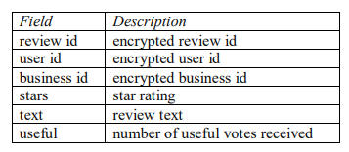
Figure:1
The data extracted is in JSON format. This unstructured data is stored using MongoDB, and the unstructured data is converted to structured form using PostgreSQL. It is a relational database management system that is free and open-source, emphasizing extensibility and SQL compliance.

Related Work:
Due to the rich information contained in the Yelp dataset, many past research and projects tried to use it to predict restaurants' ratings and evaluate future development.
For example, Kong, Nguyen, and Xu classified restaurants based on cultural categories and analyzed international restaurants' success mostly with Gaussian Discriminant Analysis (GDA).
Several other previous papers focused on the sentiment analysis with text content from Yelp. Xu, Wu, and Wang combined the customer reviews and ratings to conduct sentiment analysis, while Gingerich and Bochkov mainly used matrix factorization to analyze text information and predict Yelp ratings.
Other than Yelp reviews, Tang, Qin, Liu, and Yang introduced a neural network to predict movie reviews. When considering text analysis, they claimed that matrix-vector multiplication would be more effective than vector concatenation. So far, most research works on text analysis of customer reviews.
In this project, we apply non-text features to predict restaurants ratings and aim to work on a region-based analysis instead of a user-based analysis to provide suggestions to Yelp restaurants.

Methodology
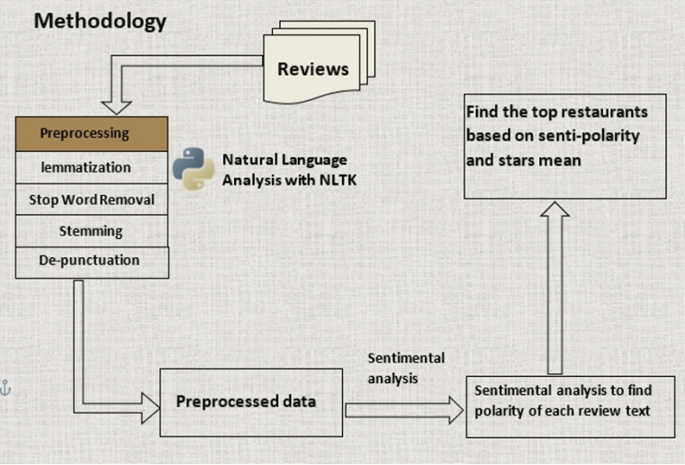
We build a chatbot that provides sophisticated restaurant recommendations for users depending on the cuisine. We briefly explain the dataset we used while creating our recommendation system. The basic workflow diagram is shown below:

Using this sentiment, polarity, and the stars means we build a chatbot that can recommend the restaurants depending on the customer's location and cuisine.

Exploratory Data Analysis

7.1 Loading the data
Business data that we fetched from the Yelp dataset was loaded to a data frame, and the first five rows are shown below,
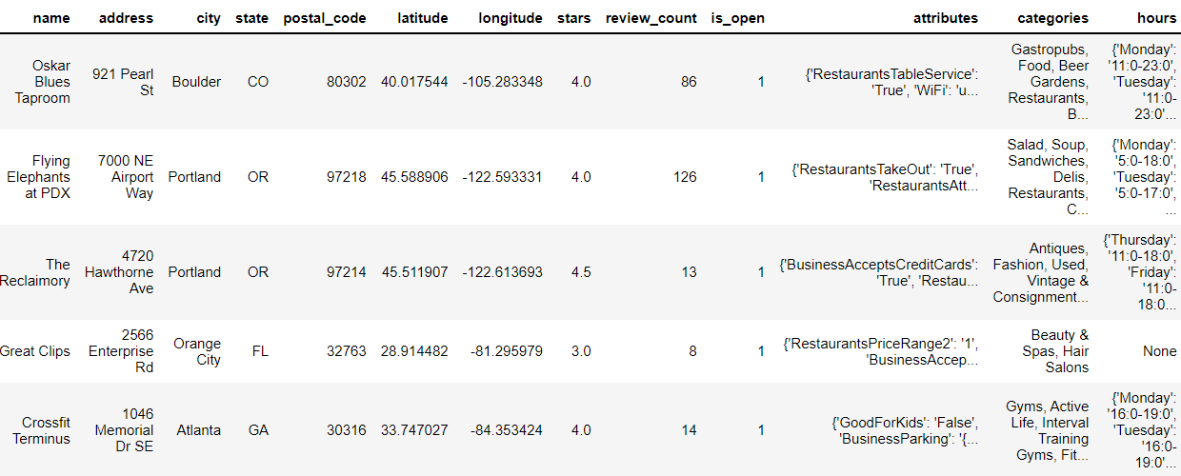

Business Dataframe with 14 columns such as ‘business_id', 'name', 'address', 'city', 'state', 'postal_code', 'latitude', 'longitude', 'stars', 'review_count', 'is_open', 'attributes', 'categories' and 'hours' with data of 160580 users.

7.2 Data Exploration
First, we are finding closed and open businesses. After that, the closed ones are removed using the drop function.
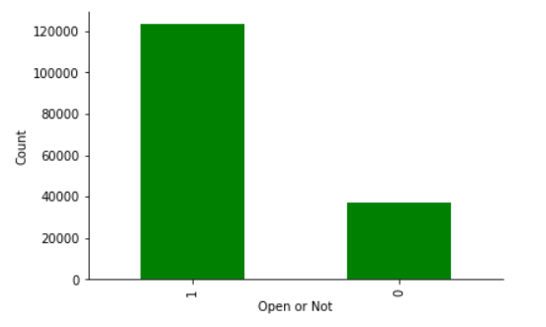
Then we convert the attribute and hour column into series, which descriptively gives the Dataframe. After that, both the hours and attribute Dataframe are joined for further processing and saved as a new file after removing the unwanted columns.
From the business dataset, in the column category, there are many categories in it. So, we are splitting it into ten different types depending on the cuisine.
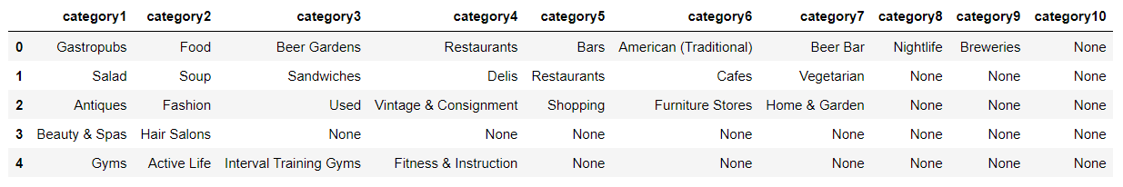
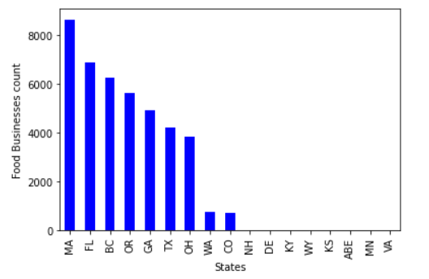
After that, we are categorizing the business count in different states.
And we find that from Canada, most of the data is from British Columbia. So, we decided to pick the restaurants from BC only for further works. Then the top category in each category is visualized for a better understanding.
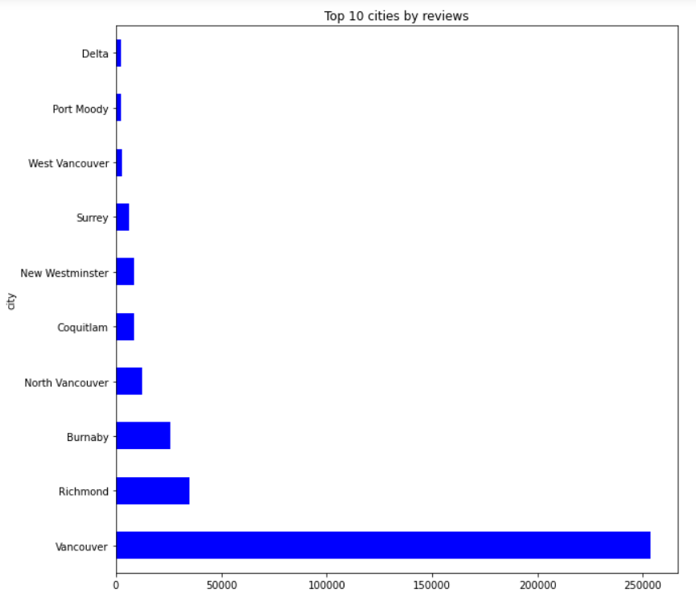
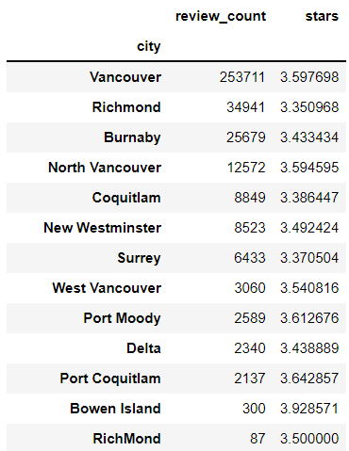
And we sort out the city names with their total review count and average stars, and the top ten cities with the highest number of reviews are plotted.

We have visualized the differences between category one and category two and we could see that both the process of the chart similar kind of data in them with not of a much difference we could see that restaurants occupying the highest proportion followed by food, Japanese, Chinese, seafood and the remaining.
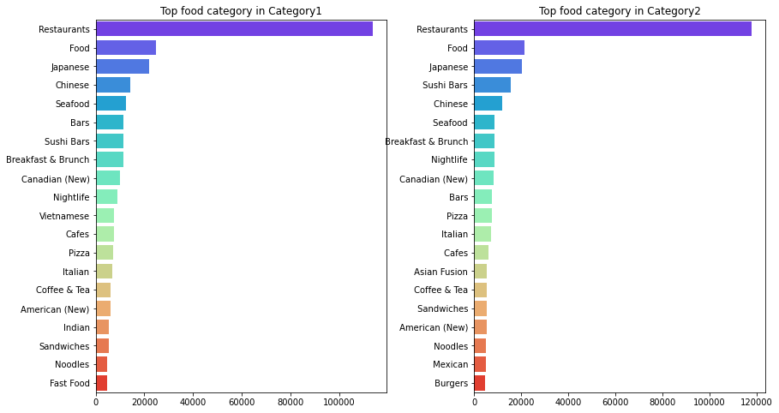
Disproof the fact that all categories are equally placed with minimal changes between them. Similarly, we have also realized the differences between multiple categories, and all give us the same result.

- Data Pre-processing
It becomes necessary to split the test data before data preprocessing, ensuring that we won't accidentally pick up any patterns from the test data. Any exploration or validation done on the test set will demise the whole purpose of having a test set.
Using a test set for validating and tweaking the model will make our model better suited for test data. This process can't check for the model's regularization, which is the primary purpose of having a test set. So, it is always better to split the data into three sets: training, holdout (validation), and test set. As we are holding out a part of the training set, during cross-validation and RandomSearchCV, we moved forward with just the train and test set.
The test data set is generated using Stratifiedshufflesplit, which creates an equal proportion of distribution of class labels evenly between train and test dataset. For instance, if our dataset has less than 1% of data for the 1-star class, a random shuffle split may give only a negligible portion of it to the test set. So, we can't determine whether our model works well for that class. So, a stratified shuffle split has been used to ensure that both training and test sets have the same distribution of types.
After basic cleaning, stop words that do not add meaning to a sentence are removed. Next, using PorterStemmer, we have reduced the terms to root words by stemming. Here, Stemming was chosen over lemmatization as with large datasets, the performance remains the same, but lemmatization took very long for small records.
To capture the sentiment associated with the review, we have to convert the ratings into sentiments. Hence, we have transformed the label (ratings) as below:
We vectorize the cleaned textual data and the required labels now that we have the cleaned textual information. We used the count vectorizer to create the vectors. We preferred count vectorizer over td-idf because of the time complexity and the insignificant performance difference.
In addition, we are trying to capture the sentiment behind the text, and it can be captured by measuring the similarity between the reviews. Count vectorizer focuses on similarity, whereas TD-IDF focuses on singularity.

Modeling
Machine learning algorithms, namely Logistic Regression, Decision tree classifier, KNN Classifier, Random Forest Classifier, Gradient boosting classifier, and Multinomial NB, are trained simultaneously on the vectorized data. After training the algorithms then we analyzed the confusion matrix for each algorithm. The decision tree and Random Forest classifier gave the best performance based on the confusion matrix.
But we cannot conclude just by the training set, and to confirm which algorithm is the best, we require validation. So, we performed cross-validation on each model to find the best model. Accuracy and f1 score are calculated for the six algorithms.
In other words, 1200 cross-validation models are trained to get the best model. Receiver Operating Characteristic (ROC) is considered the best matrix for an imbalanced dataset, but in the case of multiclass classification, that cannot be compared for the whole model. So, it should be done separately for three classes. Hence, we chose accuracy, and f1 score weighted to decide the best algorithm for our dataset.
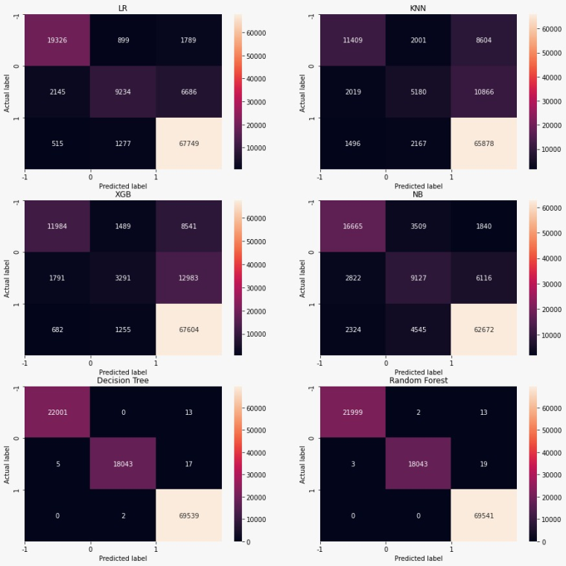

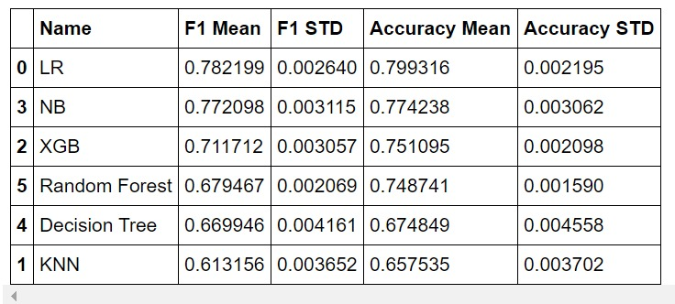
Mean, and Standard deviation for ten cross-fold validations are calculated for both F1 score and accuracy to decide the best model.

If one-fold performs better or worse than the others, it may significantly impact the mean. Though we have a standard deviation to quantify the spread of the results, if other results are closely packed, the results can be skewed. In addition, the results are shown using a boxplot. The boxplot analysis demonstrates that the optimal algorithm to use is logistic regression.
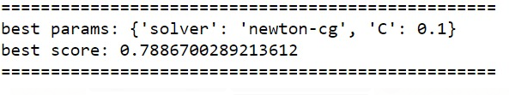
Enhancing the algorithm's parameters can boost the performance in most cases; hence we decided to perform hyperparameter tuning. Using RandomsearchCV, we performed 10*10 folds and got the best model. After the validation, Logistic Regression was chosen as the best performing model; a score of 0.78 was achieved by hyperparameter tuning.

Model Evaluation
The test data you set aside will be used to evaluate the model. The test data should be preprocessed the same way as the training data. For example, the order of the vocabulary used in the training data to train the model should be used in the test set.
When you build a data pipeline, your test data goes through the same transformations as your training data, where you need to reuse the transformer and evaluator objects used for training. Sklearn has a pipeline feature that allows data to go through the same transformer and evaluator objects. It is also flexible in creating custom transformers for custom transformations, such as the steps to be taken when clearing data. With the help of Sklearn, a model pipeline is set up to perform data cleansing, stop word removal, stemming, and finally, vectorization and transfer of data to the model.
The confusion matrix is ​​created using predictions from test sets and labels. Here, 1,0,1 are positive, neutral, and negative emotions. The model is successfully evaluated with an accuracy of 0.80 and 0.78 and an f1 score, respectively.
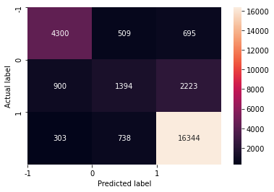

Predicting restaurants based on cuisine
We extracted restaurant data based on different cuisines, which output the top restaurants with required details for Knowledge-based Chatbot. Once we have done the entire process, we start creating a knowledge base that can be incorporated into the azure Q&A maker for the chatbot to process correctly.
To make this happen, we have created a separate function called extract restaurant which automatically creates a list of all the best restaurants available in every city for every cuisine. At the same place, we can automate the process of knowledge base creation with ease.
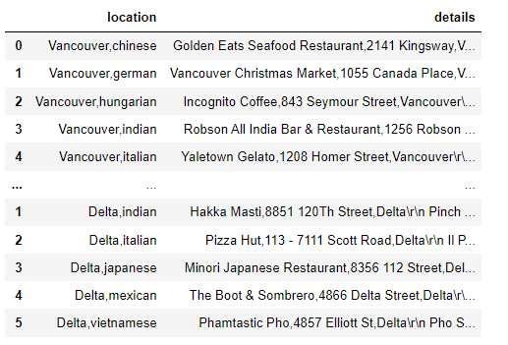
The list comprises two columns, location and Restaurant address. This list can be easily fed into the knowledge base with the import function available as an Asus service. The process can be automated to run every day once, and then the knowledge base can be updated, or it can also be across batch process, and that is any change to the list is made it gets updated.

Chatbot Building

12.1 Azure Cloud Services
We have used azure cloud-based services, mainly cognitive benefits, to create a chatbot service. This can be quickly and embedded into any web page using HTTP tags. The Q&A does a service that can be used to build a custom knowledge base that can be used to create conversational client applications.
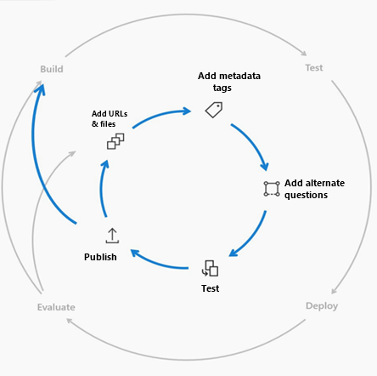
The service that does not record customer data will be only stored in the region where the service has been deployed or the dependent service instances.

- We can make use of the Q&A maker in one of these situations.
- When we have static information like PDF and URL.
- When you want to provide the same answers to a series of requests or questions.
- When you have to manage a board conversation that has static information.

12.2 Knowledge base and chatbot
Q&A maker mainly works on a knowledge base that the data is stored as a question-and-answer pair. We can create a knowledge base in more than one way; it can be imported from an Excel file or transferred from any existing knowledge base in Azure service. We have manually created the knowledge base structure here because we have created the knowledge base for the first time.
The knowledge base has been created with n number of questions and answers fast; you can save and train the KB. Since it is a machine learning service provider in issue, it gets automatically trained, and its accuracy gets better when more users are satisfied with the responses they get for their queries.
We can create multi-turn conversations with the help of prompts and active learning to improve the responses and reduce the Latent time. These multi-turn prompts allow an opportunity to connect with a different question and answer pair, allowing the client application to provide top answers and improve the search results.
The development life cycle of a Q&A maker has the following steps, creating the question-and-answer pair, training, and publishing, with permissions to integrate.
Q&A maker works on a layered ranking approach, and this creates a high quality of responses stored in azure, which also serves as a first ranking layer.

12.2 Webapp
Once the Q&A maker is being made and trained with data and tested out, we can easily host it using HTTPS tags in any website by directly embedding them. We have to create this as a service because it can be transferred to any platform hosting a service.
We have made sure to make a single application ubiquitous across all the platforms. This service can also be implemented in social media platforms like Facebook, Twitter, and Google blogs. We have made use of Google sites service to host our chatbot.

We have created the page with Google sites, made a basic web page, and included our chatbot on the right-hand side corner of the page by embedding it.
Then we have published our site so that anyone around the world can access it and benefit from it. Once we have tested our website, we have published it, and the link is as below:
This website is made mobile-friendly to dynamically rearrange itself within a small window to be easily accessed from any mobile device or tablet. In addition, we also created an Android mobile application so that an APK version could be created and shared.

12.3 Android Application
Android applications can be built using Android Studio, an IDE that can create applications deployed in the Google Play store. Android studio provides an end-to-end environment that can be used for integrated development; with his help, we have created a web app that quickly loads our chatbot in it so that it can be easily accessed with any smartphone that runs on Android and has working internet in it.

Our web app is mobile-friendly so that we did not face many integration issues with Android studio.
Some of the issues that we faced while creating the app are:
- App creation bundling issue
- Gradle build issue
- Unsupported console and HAXM installer

Future works
- Create a Ubiquitous chatbot application.
- Book Reservation through chat service.
- Implement a Batch processing module for automatic chatbot integration.
- Include more information about restaurants like amenities, open hours, etc.

Conclusion
We have created an end-to-end chatbot service that is cloud-based and can be incorporated into any web page or social media platform like Twitter, Facebook, and many more. This can also be converted into a mobile application where you can interact with the board with very minimal steps through and clickable interface and get the desired results within a few transactions, unlike traditional chatbots. Since the chatbot recommends restaurants based on the design and the city, we can modify the search and get better results as per our needs. Thereby a robust chatbot that can be ubiquitous across social platforms and webpages can be provided to any vendor who requests the service.

References
[1] Yelp Dataset Presentation: http://www.ics.uci.edu/~vpsaini
[2] http://www.ics.uci.edu/~vpsaini/files/technical_report.pdf
[3] Scaria, Aju Thalappillil, Rose Marie Philip, and Sagar V. Mehta. “Predicting Star Ratings of Movie Review Comments.”
[4] https://cseweb.ucsd.edu/~jmcauley/cse255/reports/fa15/017.pdf
[5] Chada, Rakesh, and Chetan Naik. “Data Mining Yelp Data Predicting rating stars from review text.”
[6] Li, Chen, and Jin Zhang. “Prediction of Yelp Review Star Rating using Sentiment Analysis.”
[7] https://nycdatascience.com/blog/student-works/yelp-recommender-part-1/
[8] https://cambridgespark.com/content/tutorials/implementing-your-own-recommender-systemsin-Python/index.html
[9] Arun Babu, Rahool Arun Paliwal and Syamsankar Kottukkal. “Content-Aware Collaborative Filtering for Yelp Restaurant Recommendation

